|  |  |
| --- | --- |
| Team ID | PNT2022TMID42646 |
| Project Name | Smart Farmer - IoT Enabled Smart Farming Application |

**Pre Requisites:**

**Python IDE:**

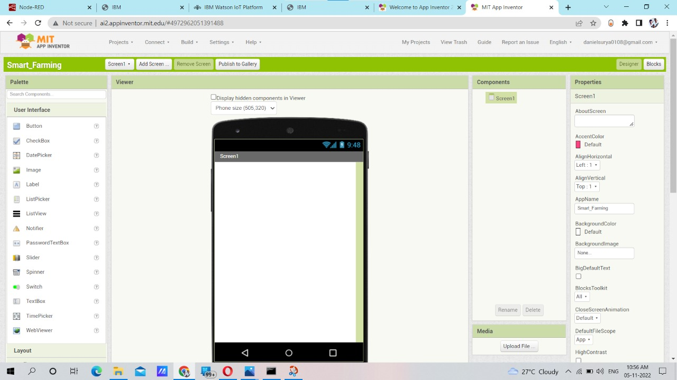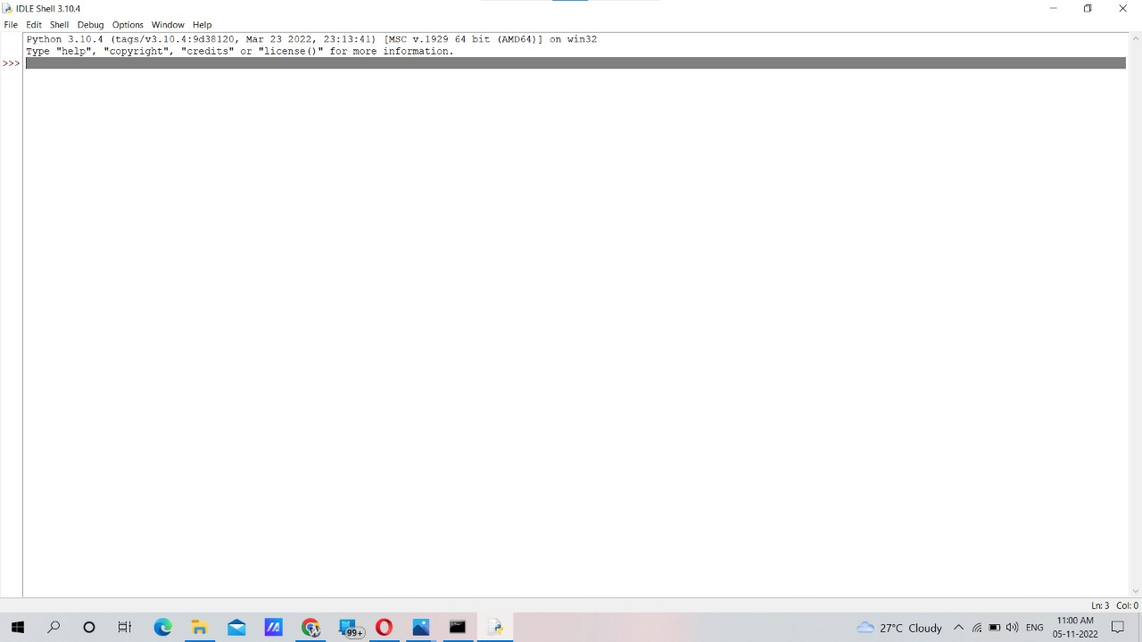

**MIT App Inventor:**

**IBM Cloud Service**

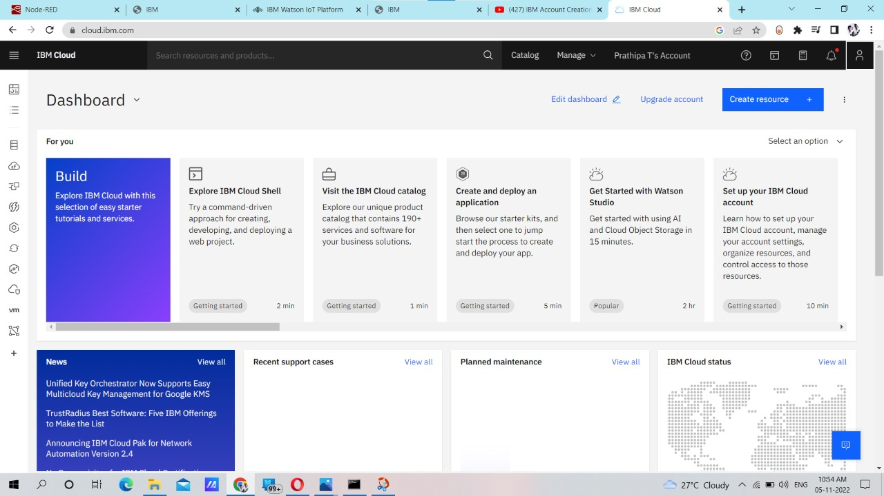

**Fast2sms:**

